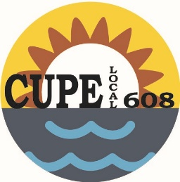
Canadian Union of Public Employees
#101-416 Westminster Ave. West
Penticton, BC V2A 1K5 website: www.608.cupe.ca
Phone: 250-493-2021
E-mail: cupelocal608@gmail.com

Acting President: Shelie Best Vice President: Vacant Recording Secretary: Leah Stubbings
Treasurer: Amanda Lust Membership Officer: Gerrie-Lynn Ward

Retirement Planning Workshop

March 7-9, 2019
Penticton Trade and Convention Centre

We will be hosting the CUPE Retirement workshop for 608 members in the spring of 2019. If you haven’t previously taken the workshop and would be interested in participating, please forward the following information to 608educationcommittee@gmail.com. Please see page 2 for additional information.

Member’s name
Partner’s name (if applicable)
Personal e-mail address (no work e-mails please)
Home/cell phone number
Anticipated retirement date

Even if you have previously expressed interest in taking the workshop, please e-mail 608educationcommittee@gmail.com to provide the requested information.

****Deadline for indicating interest is December 1, 2018.****

Posted: October 13, 2018
Page 2 – Retirement Planning Workshop

Sisters and Brothers

It is never too early to start planning for retirement. The CUPE retirement workshop is extremely popular and some locals are restricting the course to their own members, making it more difficult to get 608 members the course when they want to take it. Even if you are years away from retirement, please consider getting your name in for this workshop now.

We will be offering the retirement workshop in March 2019 for 608 members. CUPE restricts this workshop to 35 participants and we hope we can fill that number with our members and their partners. Should there be more interest than we can accommodate, we will use anticipated retirement date to determine which members are selected.

Recognizing that employers may not be able to approve time off for March at this time, I am currently only looking for an expression of interest in attending. Members will be contacted early in January for confirmation of attendance.

This workshop is open to any CUPE member who has not previously taken it. Even if you are already on the retirement workshop list, please forward the information requested on the notice by the deadline of December 1, 2018.

If you have any questions, please contact Leah at 608educationcommittee@gmail.com

In solidarity,

Leah

