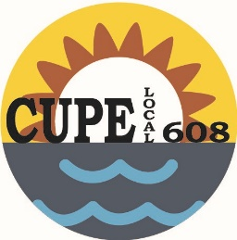
Canadian Union of Public Employees
#101-416 Westminster Ave. West
Penticton, BC V2A 1K5 website: www.608.cupe.ca
Phone: 250-493-2021
E-mail: cupelocal608@gmail.com

Acting President: Shelie Best Vice President: Vacant Recording Secretary: Leah Stubbings
Treasurer: Amanda Lust Membership Officer: Gerrie-Lynn Ward

Vote for Recording Secretary

Location:
#101 - 416 Westminster Ave.

Date: November 7, 2018
Time: 6:00 p.m.

There will be an election held at the November meeting for the position of Recording Secretary. Nominees are:

Leah Stubbings
Carol Lawrence

The following positions have been filled by acclamation. Positions effective November 7, 2018.

President: Shelie Best
Vice President (1-year term): Katherine Cook
3-year Trustee: Charmaine Daoust
Membership Officer: Gerrie-Lynn Ward

Posted October 11, 2018

