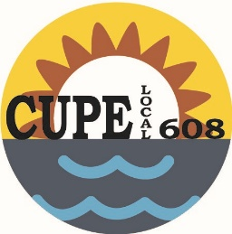
Canadian Union of Public Employees
#101-416 Westminster Ave. West
Penticton, BC V2A 1K5 website: www.608.cupe.ca
Phone: 250-493-2021
E-mail: cupelocal608@gmail.com

Acting President: Shelie Best Vice President: Vacant Recording Secretary: Leah Stubbings
Treasurer: Amanda Lust Membership Officer: Gerrie-Lynn Ward

Budget Vote

Location:
#101 - 416 Westminster Ave.

Date: November 7, 2018
Time: 6:00 p.m.

We will be presenting and voting on the 2019 budget at the November meeting.

Posted: October 23, 2018

